**WRITING TASK 1**

You should spend about 20 minutes on this task

**The table and charts below give information on the police budget for 2017 and 2018 in one area of Britain. The table shows where the money came from and the charts show how it was distributed.**

Write at least 150 words.

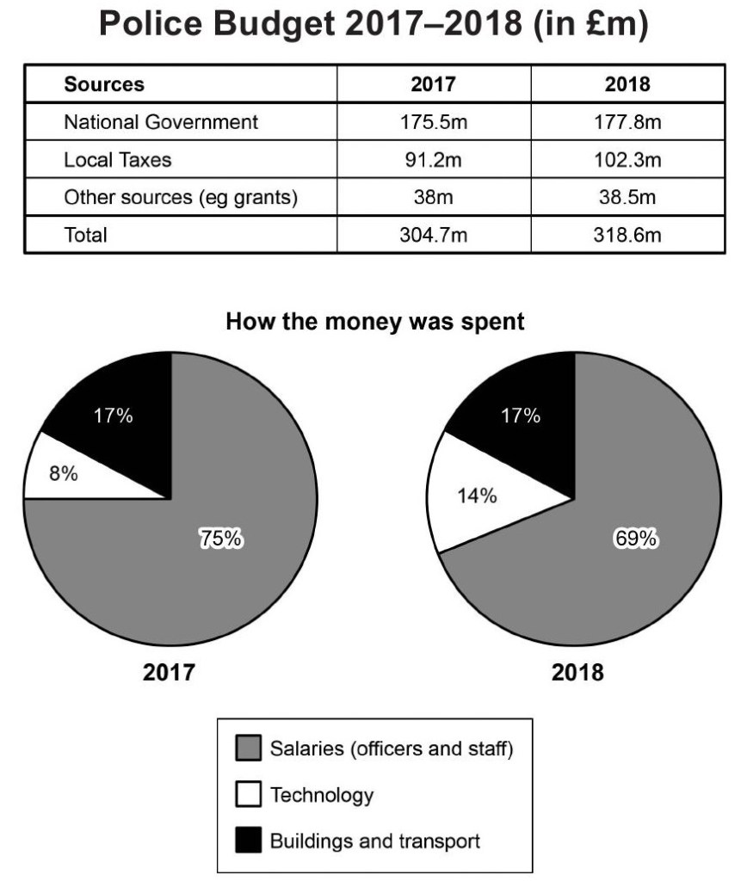

**WRITING TASK 2**

You should spend about 40 minutes on this task

Write about the following topic:

**Nowadays, a growing number of people with health problems are trying alternative medicines and treatments instead of visiting the usual doctor. Do you think this is a positive or negative development?**

Give reasons for your answer and include any relevant examples from your own knowledge or experience.

Write at least 250 words.